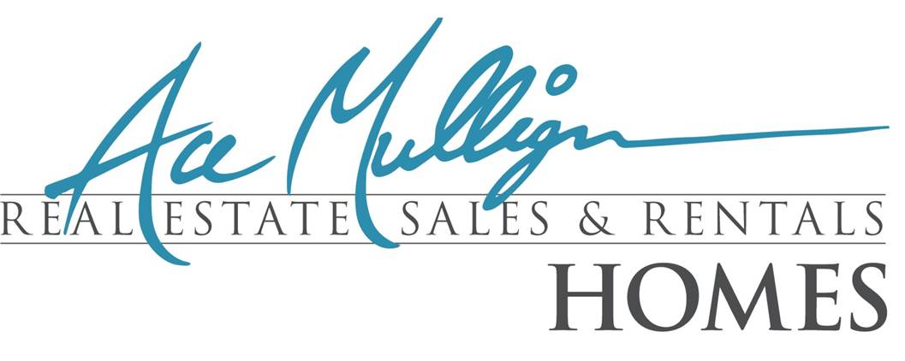

Welcome Home
We would like to thank you for choosing Ace Mulligan Homes as your housing provider. We are dedicated to working hard at earning your trust and your future business. As the largest Property Management Company in Pinal County, we have learned what common issues typically arise in a tenant/landlord relationship. We have created this quick reference guide based on many years experience and hope that it answers most of your questions and allows us to avoid many common issues. Please keep this accessible along with your lease agreement. We look forward to a long and happy relationship.

Property Manager
Ginger Mann
Office – 520-424-2244 Ext 103
Cell - 480-226-0199
Fax - 800-881-7178
ginger@acemullianhomes.com
www.acemulliganhomes.com
Utilities
Electric | Gas | Water/Sewer
APS 602-371-7171 | Southwest 602-861-999 | Coolidge 520-723-4882
SRP 602-236-8888 |  | AZ Water 520-723-5346
ED2 520-723-7741 |  | Johnson Utilities 480-987-9870

Accounting FAQ’s
When is my rent due?
Rent is due on the first of the month. We do not offer a grace period. A $10 late fee will apply to your account everyday that you are late.
How can I pay my rent?
You have a few options. You can drop rent off or mail to our location at 1662 West Hunt Hwy Suite 102, San Tan Valley. Please keep in mind rents mailed will need to be received by the first. You can also pay your rent online, please note that payments made online will incur an additional $10 service fee.
Can I make a partial payment of rent?
All payments need to be paid in full unless approved by your property manager In writing.

What do I need to do to give my notice
Notice to vacate the property must be in writing. You must also fulfill your lease term.

Maintenance

Routine Maintenance
Please submit all maintenance work orders through your tenant portal and please provide the best contact info for a vendor to contact you. Your work order will be assigned to one of our approved vendors. Our vendors will call you directly to schedule an appointment.
Emergency Maintenance
Call 520-424-2244 Ext 110
Emergencies are defined as an event that poses immediate danger to life and/or property. For example complete plumbing back up, heater/A/C failure when temperature is below 60 or above 80 degrees. Continuous interior water leak, water heater failure, etc.

Trouble shooting Maintenance issues

How often do I replace my air filter?
Make sure that you replace your filter at least once a month.

If my Heater/A/C fails?
Make sure the air filter is clean. Make sure the circuit breaker is on. Turn on and back on if you are unsure. Make sure the thermostat is in the auto position with the desired temperature.
In the event of a water leak?
Shut the water off at the location of the leak or use the main shutoff if your are unable to locate the source. Dry up any water so as not to damage the affected area and contact our emergency number.
Toilet Back Up?
Try Plunging the toilet. Please note that if a plumber is called and retrieves anything not suitable to be flushed down the toilet, you may be charged.
No Power?
Check breaker/fuse box. Reset GFI plug. Check to see if outlet is run off a wall switch

Smoke Detectors?
If the smoke detector is making a chirping sound you will need to replace the batteries.

Garbage Disposal Fails?
Unplug the disposal and check for debris blockage, plug back in and press reset button ( small red button at the bottom of the disposal). You can also try to turn the unit manually with an allen wrench.
Who is responsible for yard maintenance?
Yard maintenance is the responsibility of the tenant. Please follow all city and neighborhood rules and regulations.
Trash Can?
Trash cans need to be stored on the side of the home behind the gate. Most HOA’s are very strict and you may be fined if you continue to leave them left out.
Garage door does not open?
If light flashes when opening, your sensors may need to be realigned. This can be done by having one person slightly bend the sensors until they are aligned while another person pushes the close button. If the door is off track do not try to correct the problem. Place a work order on your on line portal.
Can I make changes to the property?
You can only make improvements or changes to the property as long as you have PRIOR WRITTEN approval from your landlord.

Is it my responsibility to have the carpets and home cleaned?
YES, The home needs to be cleaned, and carpets need to be professionally cleaned and have a receipt at the time of move out.
Who do I call for a move out inspection?
Please call your property manager to schedule an inspection. You will need to be completely moved out of the home at this time, however utilities will need to be on in order to do the inspection.

What if I receive an HOA Violation?
You are responsible to pay any fines imposed and to rectify the matter immediately.

Hot water heater issues?
Electrial units – Turn off the breaker to the unit, open the panel on the side of the unit and reset button. Flip the breaker back on. Check the thermostat on the tank for a proper setting. Gas units – Check to make sure the pilot light is lit, if not call gas company. Adjust thermostat setting.

